Internship Task-1
1.Introduction section:
What is an embedded system?
An embedded system is a special-purpose computer system designed to perform a specific function or a limited set of functions within a larger device. Unlike a general-purpose computer (such as a laptop or desktop), an embedded system is dedicated to a particular task.

2.Real world Application
- Automotive: Engine Control Unit (ECU), ABS, airbags, parking assist.
- Home Appliances: Washing machines, microwave ovens, refrigerators, air conditioners.
- Healthcare: ECG machines, patient monitors, pacemakers, infusion pumps.
- Industrial Automation: PLCs, robotic arms, CNC machines, conveyor systems.
- Banking: ATMs, POS machines, biometric attendance systems.
- Agriculture: Automatic irrigation systems, soil moisture monitoring, greenhouse automation.
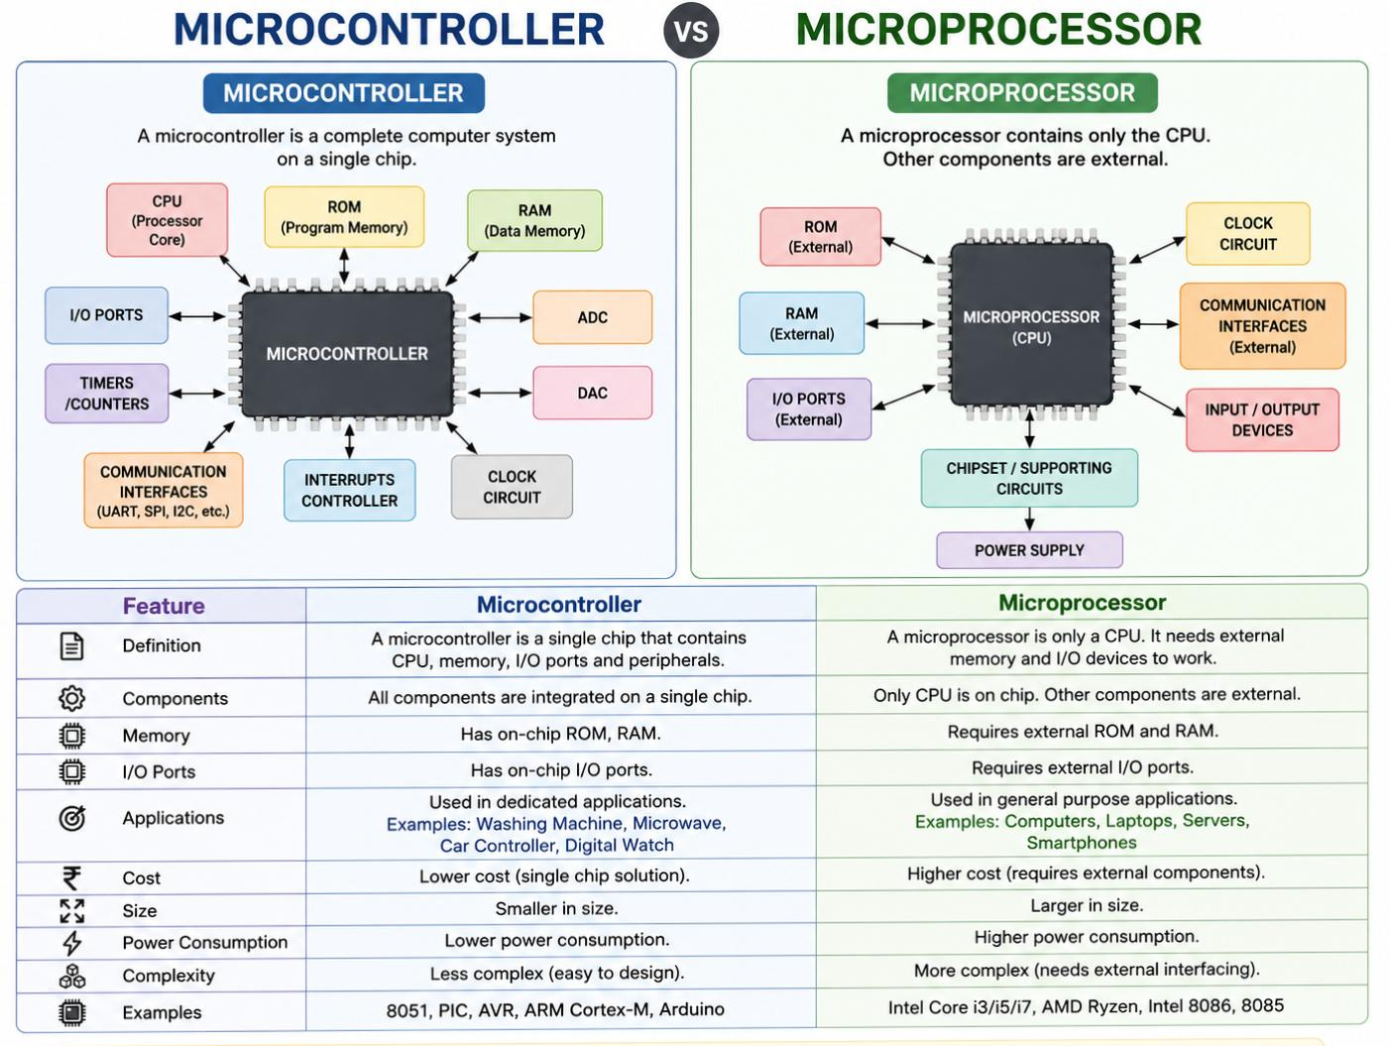
3.Difference between microcontroller and microprocessor

Mini project: Smart Temperature Monitor
The Smart Temperature Monitor designed and simulated using Tinkercad Circuits.
A Smart Temperature Monitor is a simple embedded system that continuously measures the surrounding temperature using a temperature sensor and an Arduino Uno. It monitors the temperature in real time and provides an alert when the temperature exceeds a preset limit. This project demonstrates the basic concepts of sensing, data processing, and output control, making it useful for learning embedded systems and for applications in homes, industries, and environmental monitoring.
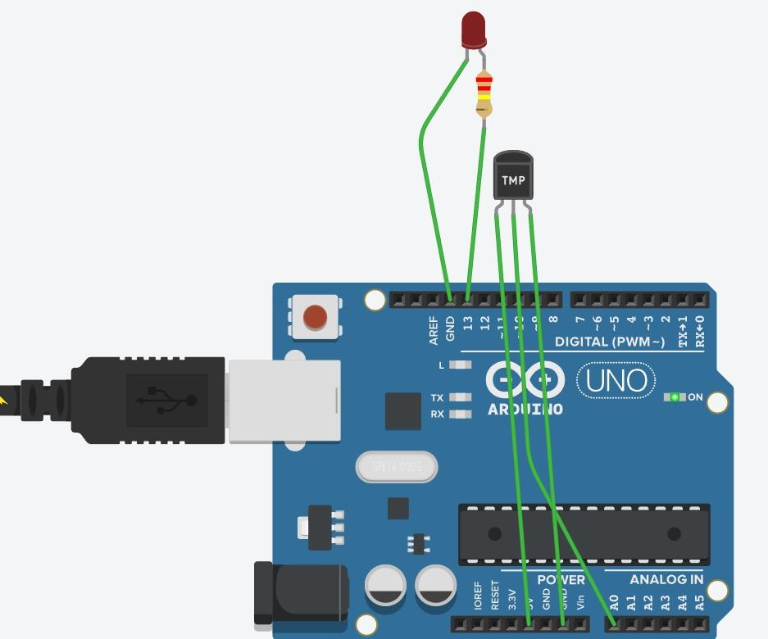
Circuit diagram:-

Explanation

Arduino UNO

Arduino UNO is the main controller of the project.

It reads the temperature from the TMP36 sensor and controls the LED.

TMP36 Temperature Sensor

The TMP36 is an analog temperature sensor.

It measures the surrounding temperature and produces an analog voltage proportional to the temperature.

Power Supply Connection

The left pin (VCC) of the TMP36 is connected to the 5V pin of the Arduino.

This provides power to the sensor.

Ground Connection

The right pin (GND) of the TMP36 is connected to the GND pin of the Arduino.

This completes the electrical circuit.

Signal Connection

The middle pin (Output) of the TMP36 is connected to Analog Pin A0 of the Arduino.

The sensor sends the temperature value as an analog voltage to A0.

LED Connection

The positive terminal (anode) of the LED is connected to Digital Pin 13 through a 220 Ω resistor.

The resistor limits the current and protects the LED from damage.

LED Ground

The negative terminal (cathode) of the LED is connected to the GND pin of the Arduino.

Working Principle

The TMP36 continuously measures the ambient temperature.

The Arduino reads the analog voltage from pin A0.

The Arduino converts the voltage into temperature in degrees Celsius (°C).

The temperature value is displayed on the Serial Monitor.

Applications

Room temperature monitoring

Industrial temperature monitoring

Smart home automation

Fire warning systems

Greenhouse monitoring
LED ON Condition:
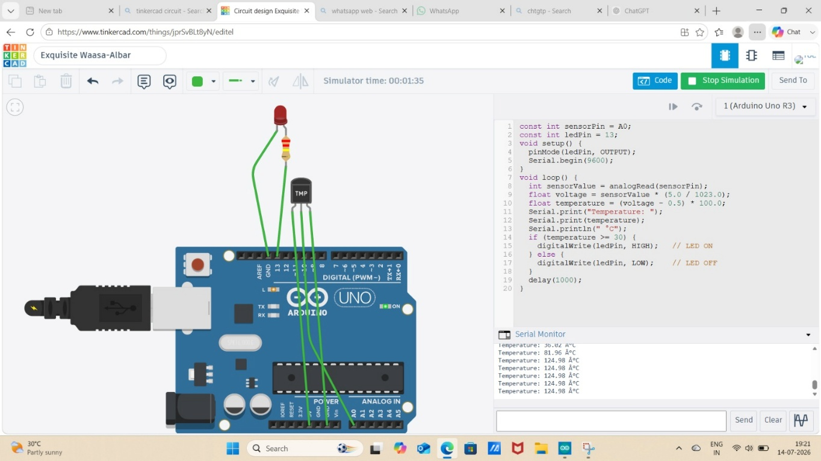
When the measured temperature is 30°C or higher, the Arduino sends a HIGH signal to digital pin 13, turning the LED ON. This indicates that the temperature has exceeded the preset limit.

Logic of program:
If (temperature >= 30) {
digitalWrite(ledPin, HIGH); // LED ON
} else {
digitalWrite(ledPin, LOW); // LED OFF
LED OFF Condition:
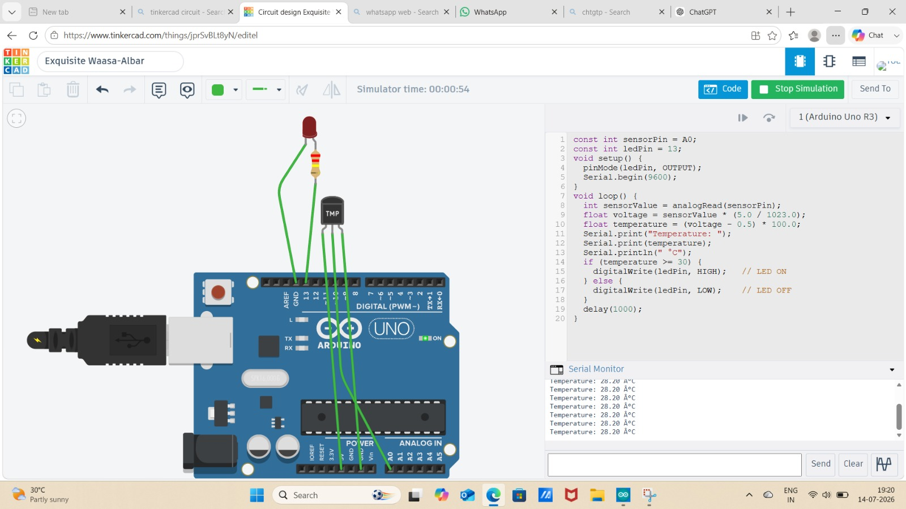
When the temperature is less than 30°C, the Arduino turns the LED OFF, indicating that the temperature is normal
The Arduino continuously reads the temperature from the TMP36 sensor. If the temperature is 30°C or above, the LED turns ON. If the temperature is below 30°C, the LED turns OFF. The temperature is also displayed on the Serial Monitor in real time.

Source code :
Const int sensorPin = A0;
Const int ledPin = 13;
Void setup() {
pinMode(ledPin, OUTPUT);
Serial.begin(9600);}
Void loop() {
Int sensorValue = analogRead(sensorPin);
Float voltage = sensorValue * (5.0 / 1023.0);
Float temperature = (voltage – 0.5) * 100.0;
Serial.print(“Temperature: “);
Serial.print(temperature);
Serial.println(“ °C”);
If (temperature >= 30) {
digitalWrite(ledPin, HIGH); // LED ON
} else {
digitalWrite(ledPin, LOW); // LED OFF
}
Delay(1000); }

